**Review of Correlation and Simple Linear Regression**

**Correlation**

A correlation coefficient is a number between -1 and 1 which measures the degree to which two variables are linearly related. If there is perfect linear relationship with positive slope between the two variables, we have a correlation coefficient of 1; if there is positive correlation, whenever one variable has a high (low) value, so does the other.

If there is a perfect linear relationship with negative slope between the two variables, we have a correlation coefficient of -1; if there is negative correlation, whenever one variable has a high (low) value, the other has a low (high) value.

A correlation coefficient of 0 means that there is no linear relationship between the variables.

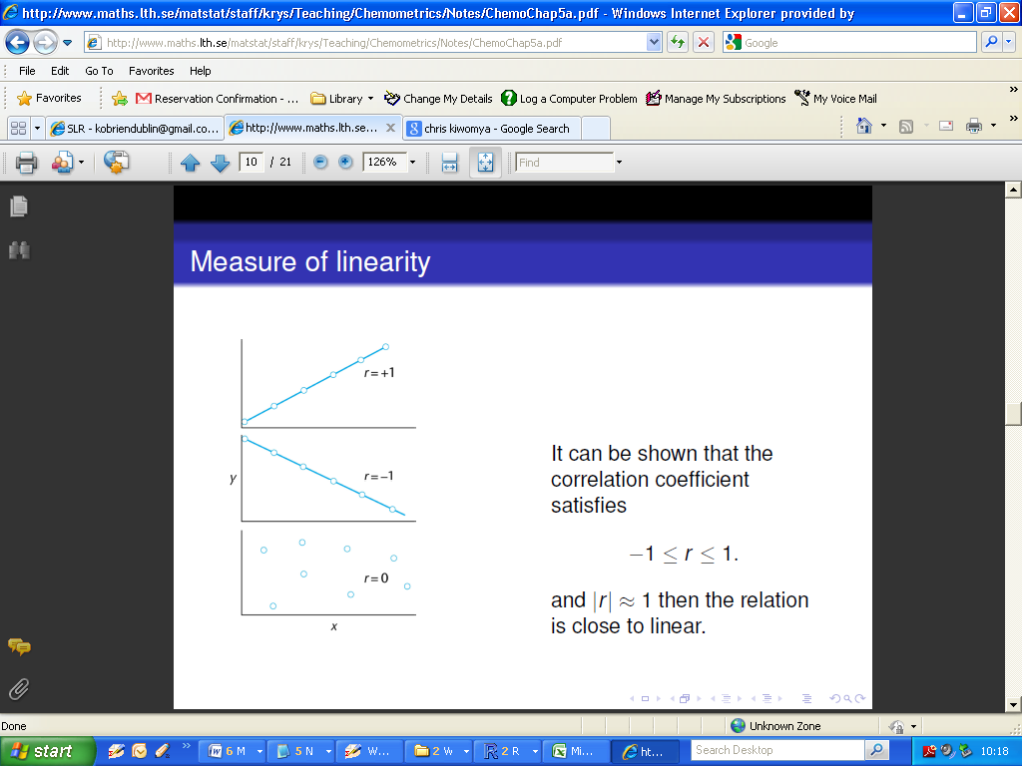

**Pearson's Product Moment Correlation Coefficient**

Pearson's product moment correlation coefficient, usually denoted by ***r***, is one example of a correlation coefficient. It is a measure of the linear association between two variables that have been measured on interval or ratio scales, such as the relationship between height in inches and weight in pounds.

However, it can be misleadingly small when there is a relationship between the variables but it is a non-linear one.

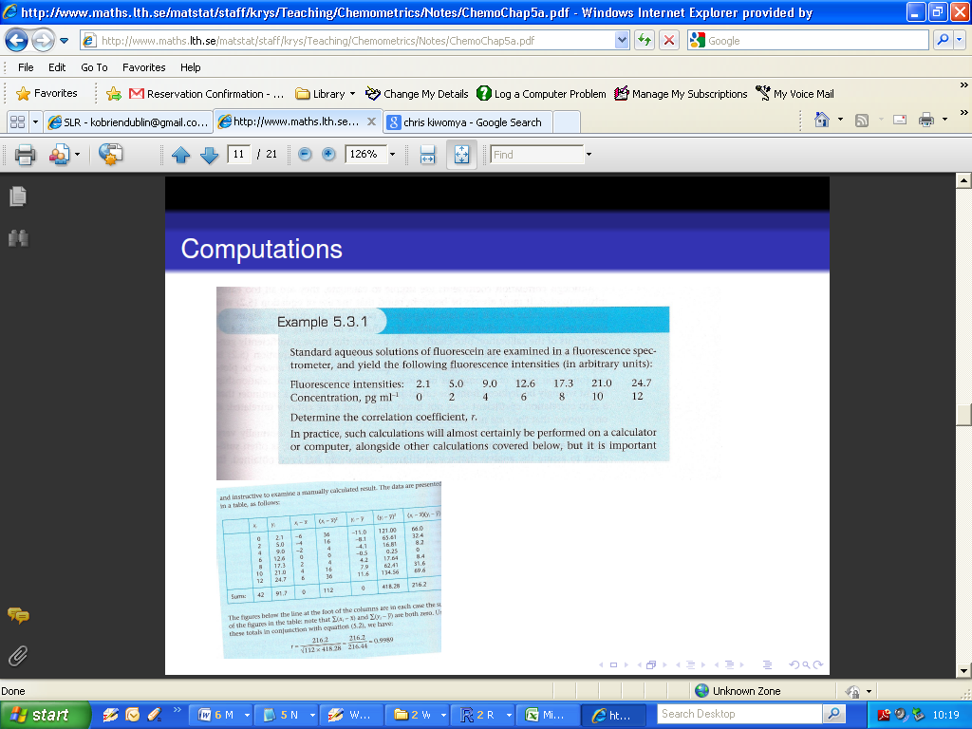

We can determine the Pearson Correlation coefficient in R using the cor() command.

To get a more complete statistical analysis, with formal tests, we can use the command cor.test()

The interpretation of the output from the cor.test()procedure is very similar to procedures we have already encountered. The null hypothesis is that the correlation coefficient is equal to zero. This is equivalent to saying that there is no linear relationship between variables.

|  |
| --- |
| > Conc=c(0,2,4,6,8,10,12)  > Fluo=c(2.1,5.0,9.0,12.6,17.3,21.0,24.7)  >  > cor(Fluo,Conc)  [1] 0.9988796  >  > cor.test(Fluo,Conc)  Pearson's product-moment correlation  data: Fluo and Conc  t = 47.1967, df = 5, p-value = 8.066e-08  alternative hypothesis: true correlation is not equal to 0  95 percent confidence interval:  0.9920730 0.9998421  sample estimates:  cor  0.9988796 |

Remark upon the following outputs:

* The correlation coefficient: **0.9988796 (**very strong positive linear relationship)
* The 95% confidence interval for the correlation coefficient estimate: **(0.9920730,0.9998421)**
* p-value: **8.066e-08** (i.e. Reject the Null Hypothesis)

There are procedures, based on ***Pearson’s coefficient***, for making inferences about the population correlation coefficient. However, these make the implicit assumption that the two variables are jointly normally distributed.

When this assumption is not justified, a non-parametric measure such as the Spearman Rank Correlation Coefficient might be more appropriate.

(Let us assume for a moment that both ***Fluo*** and ***Conc*** are not normally distributed)

The specification is the same as for Pearson’s test, with the additional argument “method=spearman”).

The interpretation is very similar, but there are no confidence intervals for the estimates.

|  |
| --- |
| > cor.test(Conc,Fluo,method="spearman")  Spearman's rank correlation rho  data: Conc and Fluo  S = 0, p-value = 0.0003968  alternative hypothesis: true rho is not equal to 0  sample estimates:  rho  1 |